

Sri Lanka Institute of Information Technology

**Enterprise Standards and Best Practices for IT Infrastructure**

IT13120658

M.L.P.Silva

Weekday IT

GitHub URL:

1. Open VMware Workstation

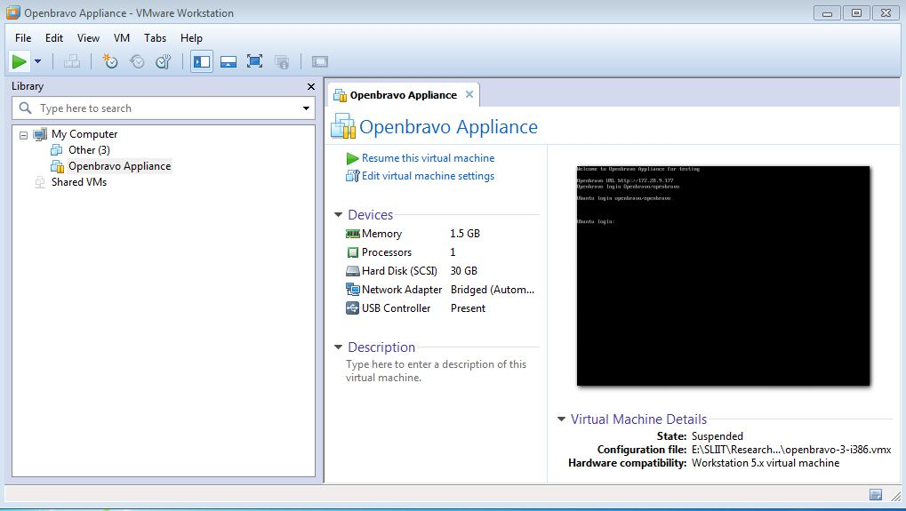

1. Open new virtual machine

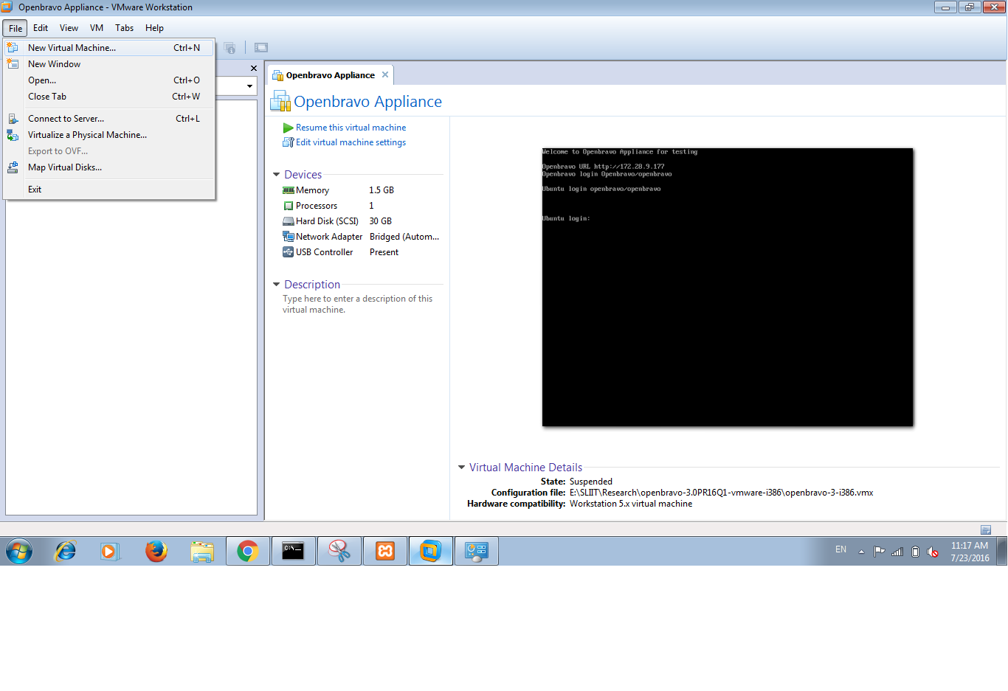

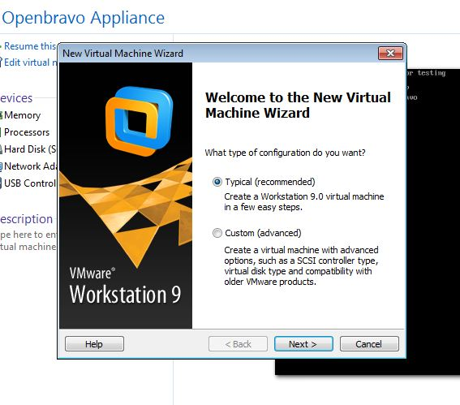

1. Clicking the next button give a specific name for that created virtual machine

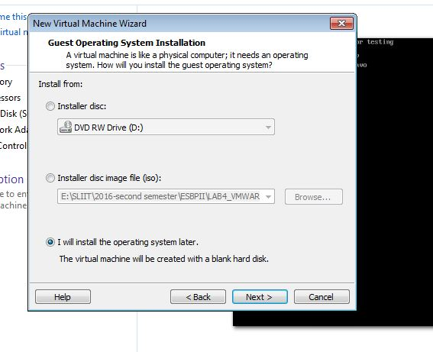

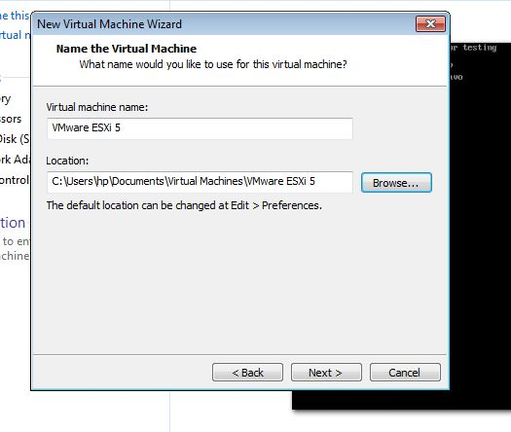

1. Specify the Disk Capacity for the virtual machine and make it as store virtual disk as a single file. And click the Next button to continue.

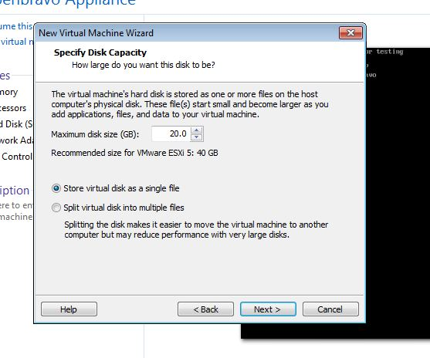

1. Click finish to create the new virtual machine and start installing VMware EXSi

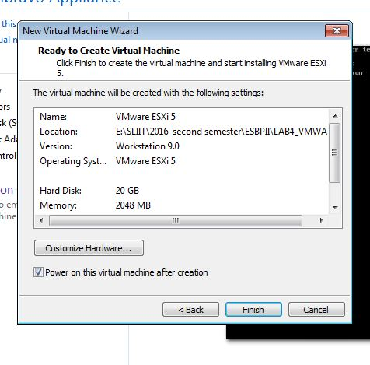

1. Specify the amount of memory allocated to this virtual machine and click the close button. Then click the customize the hardware.

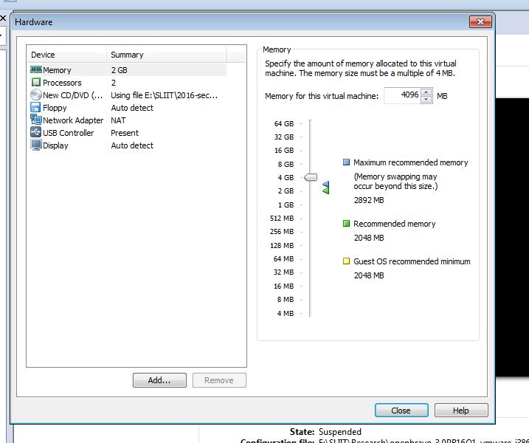

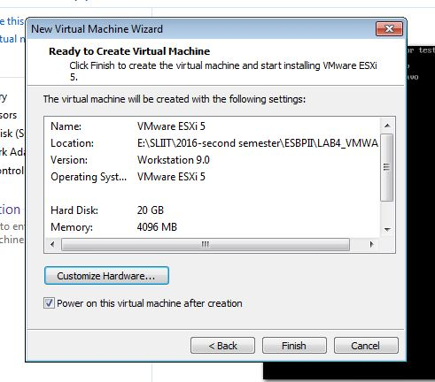

1. Now that everything is ready, we can finally install ESXi. With the USB pen drive in place, power up the server and wait for the boot screen to show up. Select the “ESXi-xxx …. installer”  option and press **Enter.**It takes roughly a couple of minutes before the required binaries are loaded.

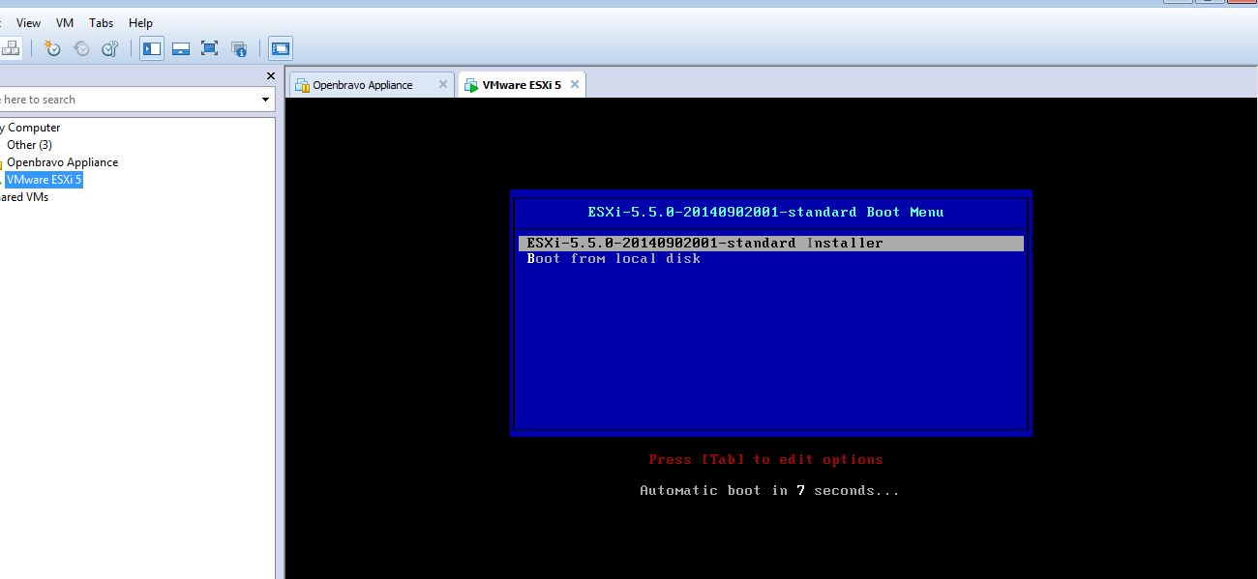

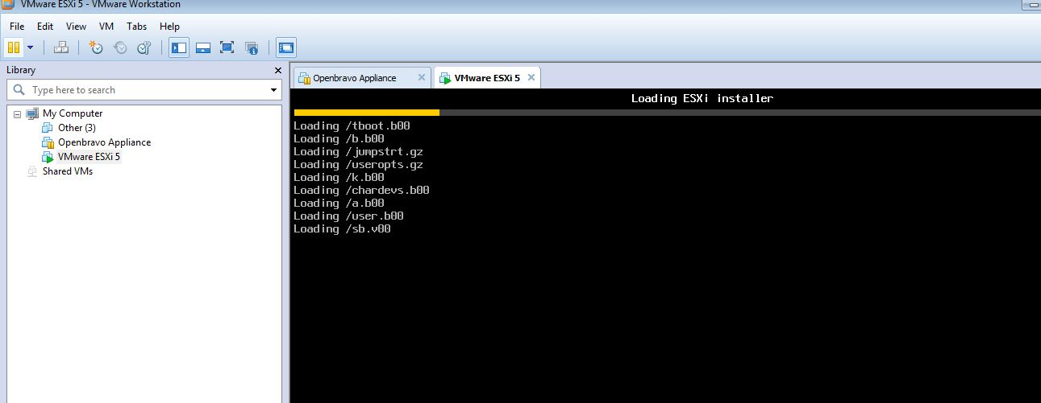

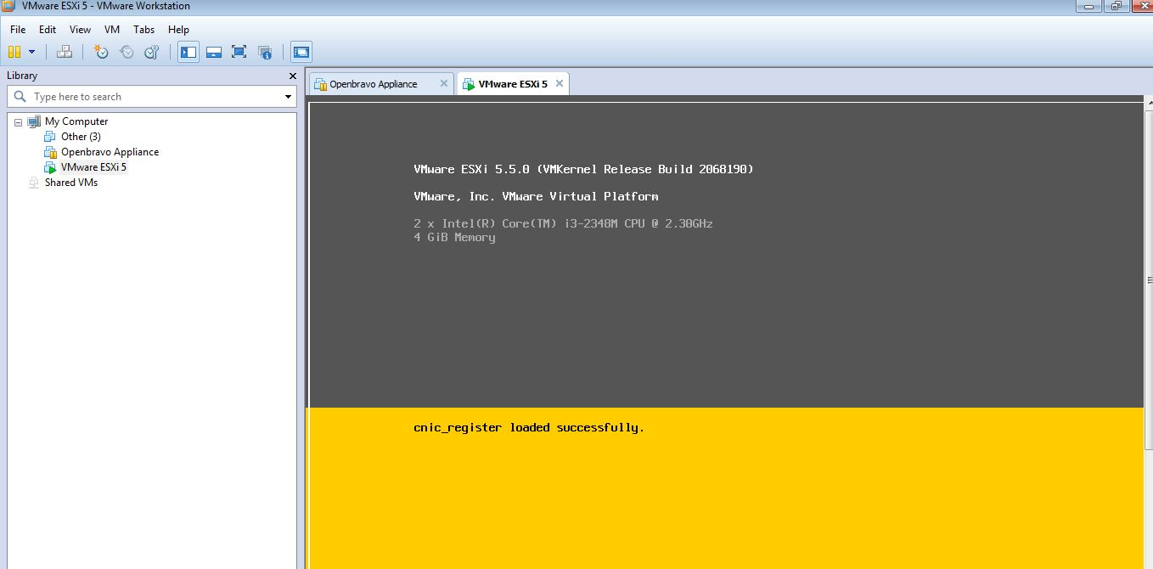

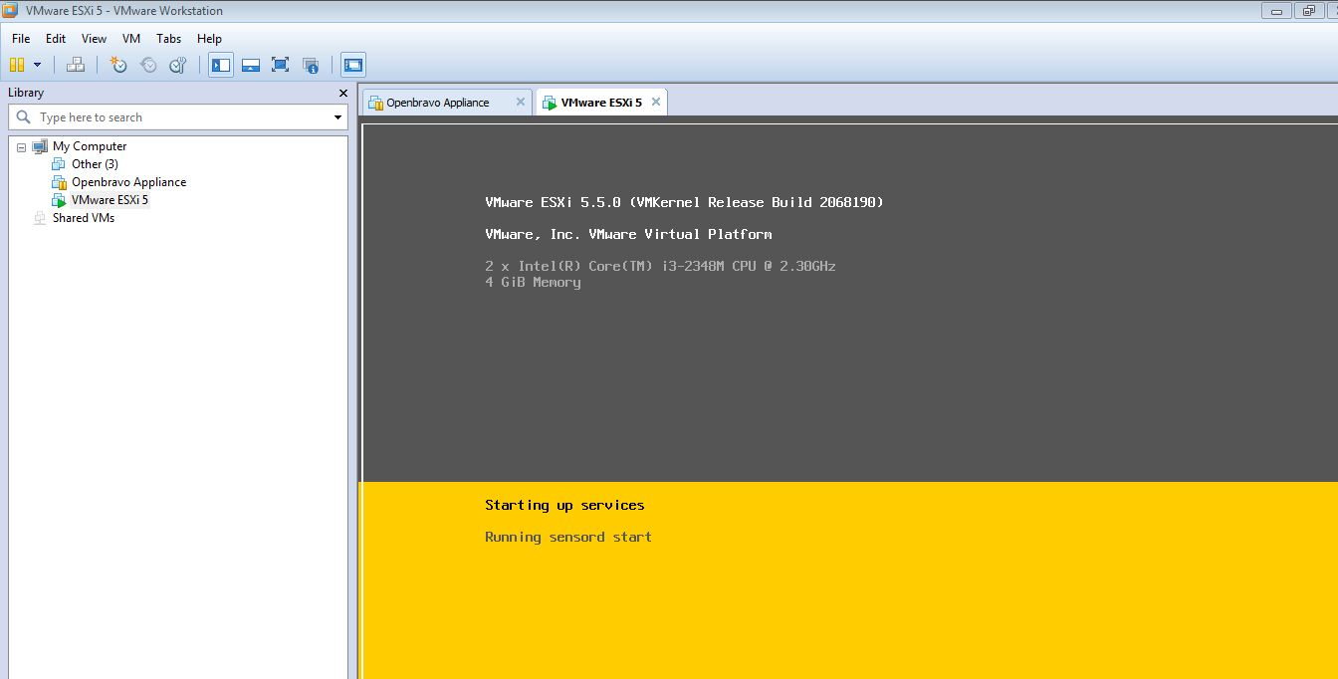

1. Press **Enter** to continue with the installation. At the next screen, press **F11** to accept the EULA. This is immediately followed by a device scan.

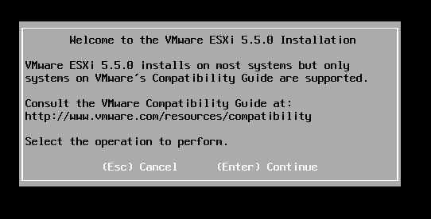

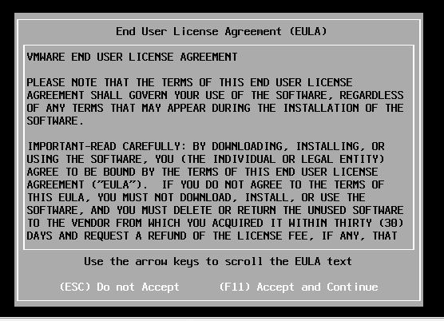

1. Using the arrow keys, select the drive on which you want ESXi installed. Press **Enter.**

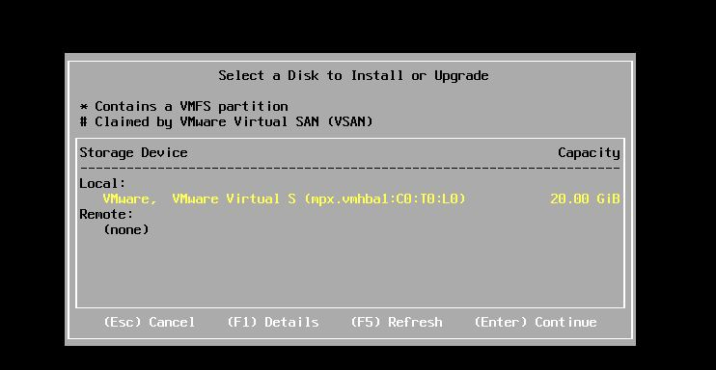

1. Next, specify the keyboard layout. The default layout us set to “US Default”. Change as needed and press **Enter** to continue.

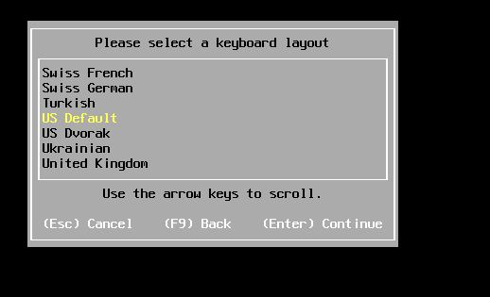

1. Create the root account’s password. Press **Enter** to accept once you do. Make sure you don’t forget the password!

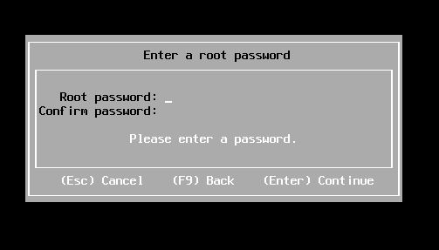

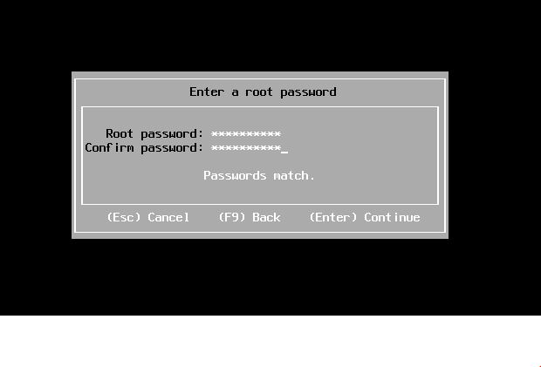

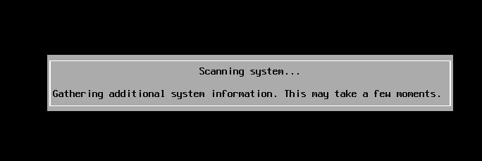

1. Pressing **F11** confirms your disk selection. If ESXi is already installed, you’ll be prompted to either upgrade the current version or preserve it.

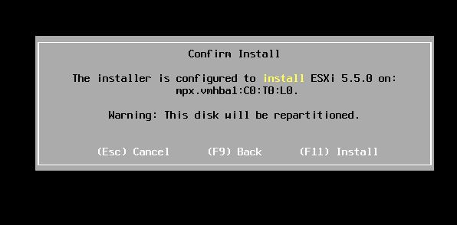

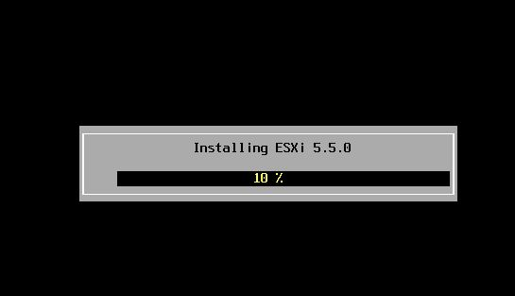

1. The installation takes a few minutes to complete. Once done, press **Enter** to reboot the server.

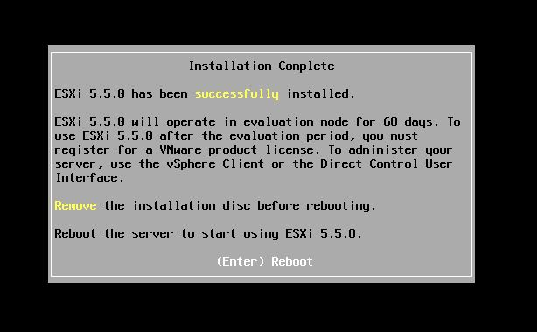

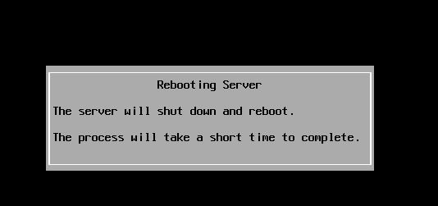

1. When the server is back up, the ESXi host should have acquired an IPv4/6 address or both assuming you have a DHCP server on your network. In a production environment, you should stick to using static addresses or DHCP reservations.

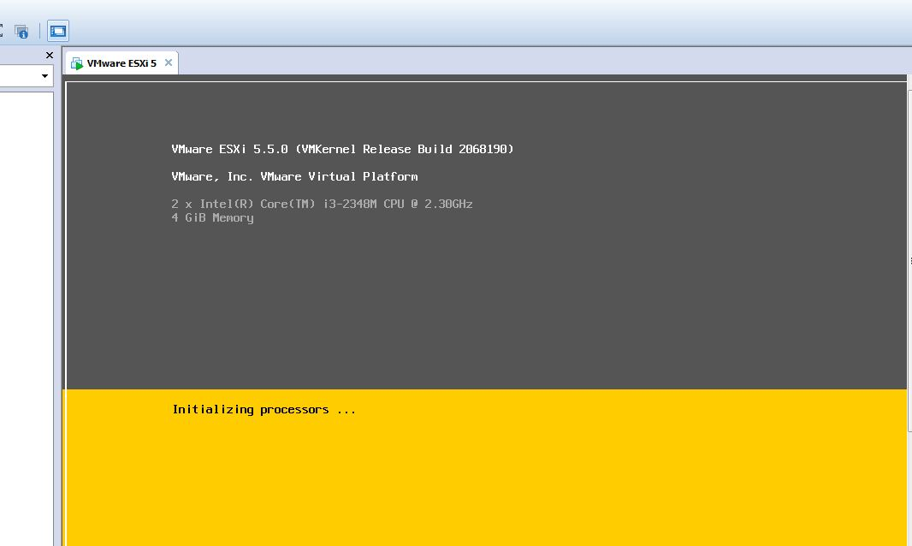

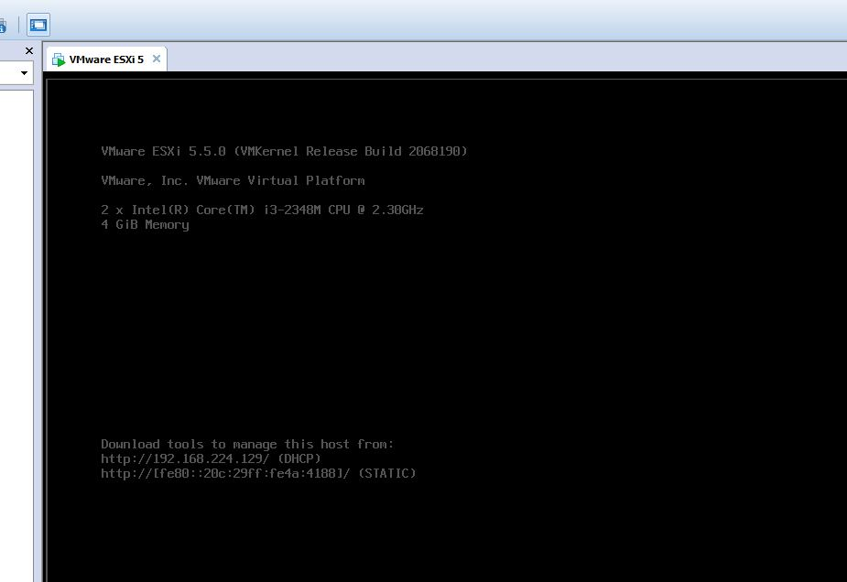

1. You need to install the vSphere client first. Using any browser, go to https://<ESXi IP address>. Alternatively, you can download the latest (or any other version) from [here](https://kb.vmware.com/selfservice/microsites/search.do?language=en_US&cmd=displayKC&externalId=2089791). Asclick on the “vSphere Client for Windows” link to download the vSphere client installer. Install it as you’d normally do with any other software package.

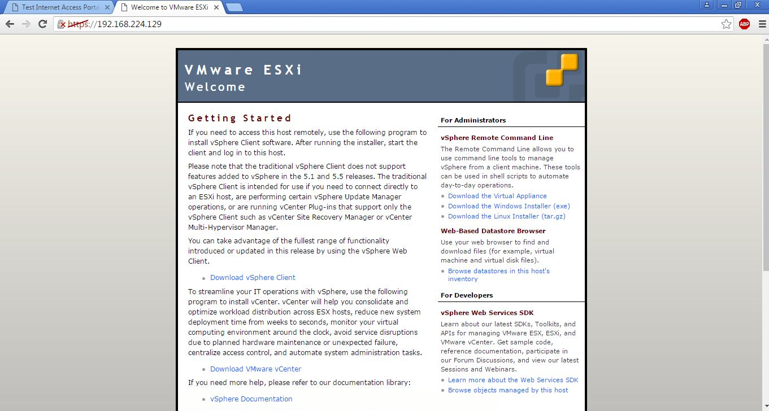

1. Using the vSphere client, log in with the root account and corresponding password. Type in the IP address of the ESXi host, the credentials and press **Login**.

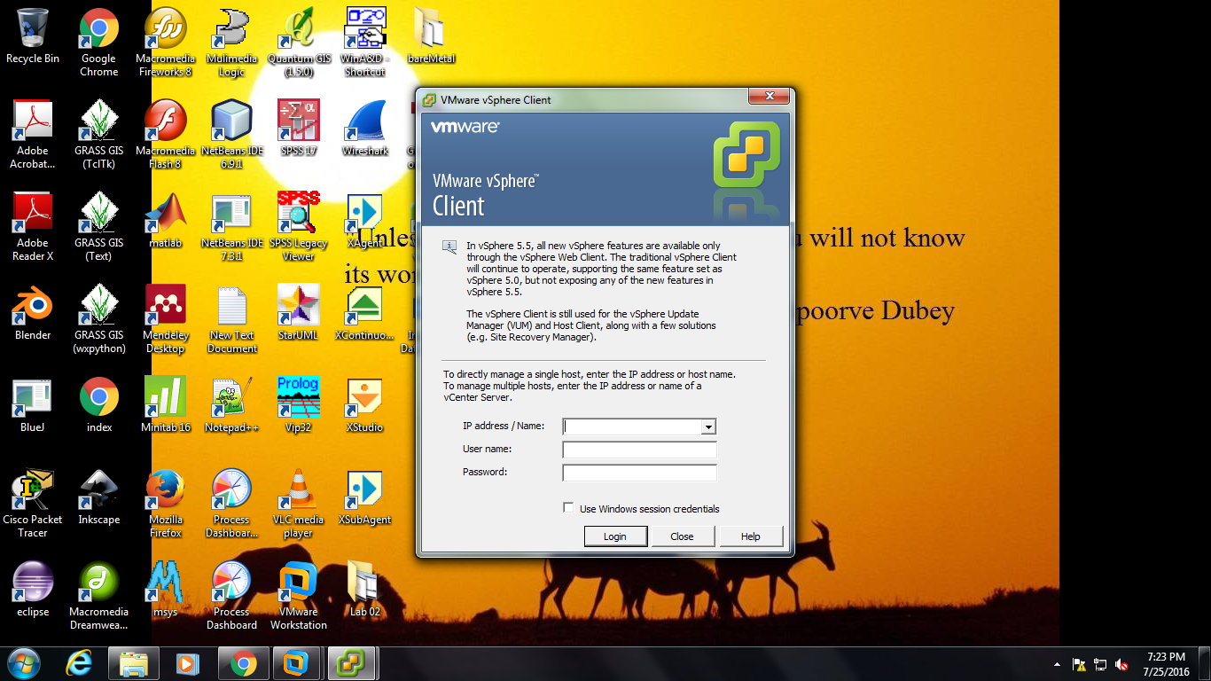

1. You can safely ignore any certificate warnings for the time by pressing **Ignore**. At this point it’s looking pretty much bleak. But this is to be expected. We haven’t created any virtual machines yet!

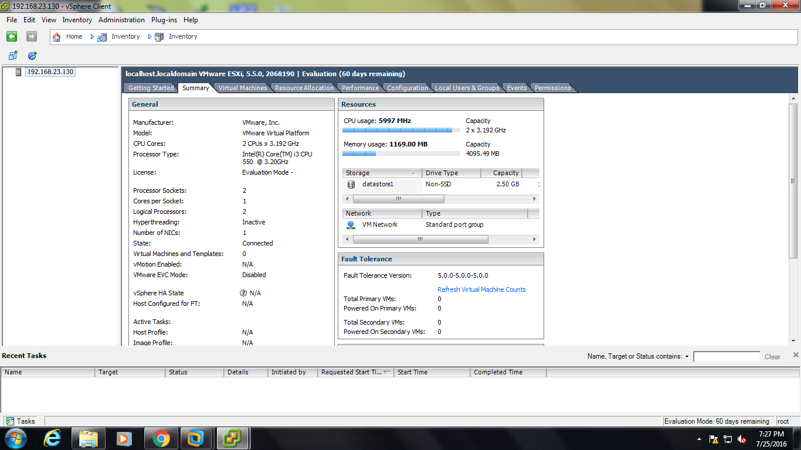

1. After installing ESXi, unless already familiar, you should explore the various Hardware and Software settings under the “Configuration” tab. I’ve selected “Storage” to check if a Datastore has been created. A datastore is just a storage location where the files making up a virtual machine reside.

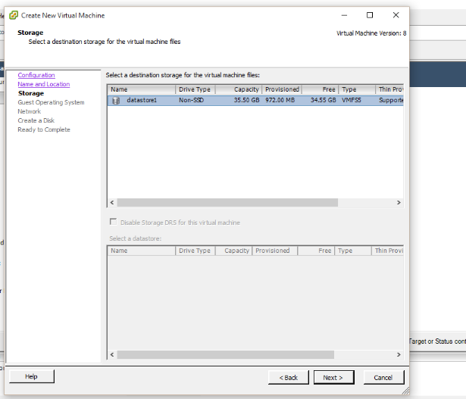

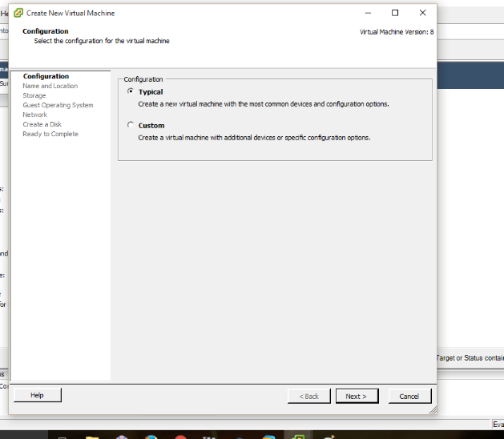

1. create our first virtual machine. Right-click on the ESXi host’s IP address (or hostname) and select “New Virtual Machine” or pressing Ctrl-N. Just follow the vm creation wizard.

